Life Wheel

Rate your functioning in each area of your life on a scale of 1 (poor) to 5 (excellent) and plot it on the wheel.
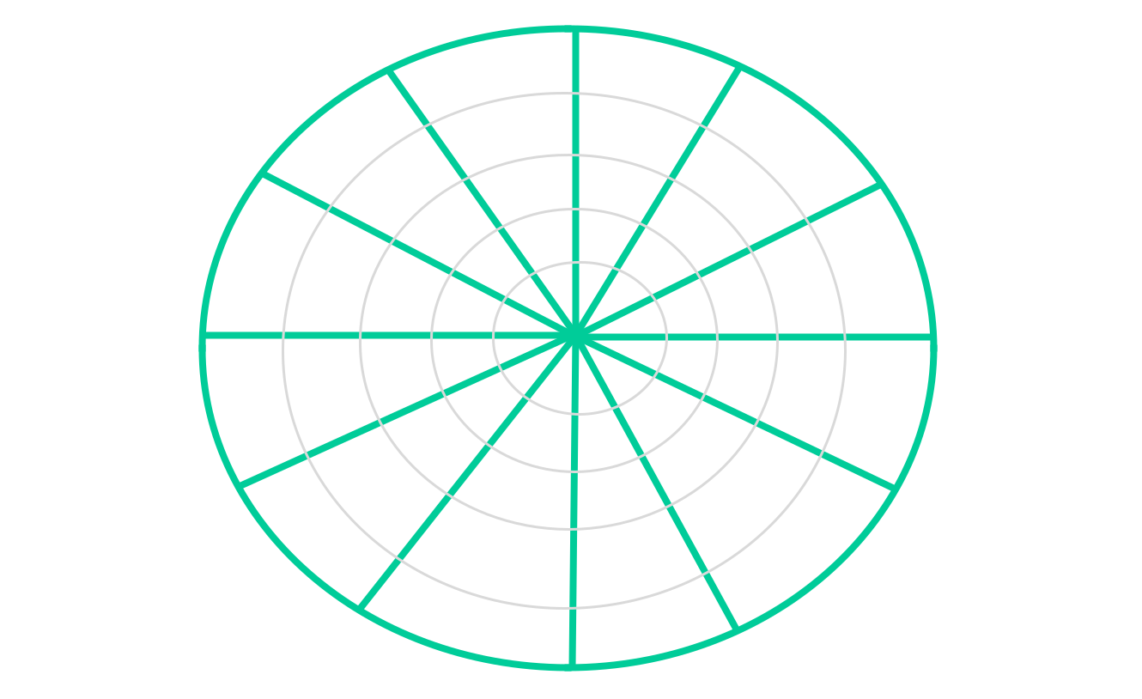

Label each “pie” slice, 12 in total, with a different area of your life. See examples below:
- Hobbies, Fun, Self-care
- Finances, Work, Spirituality
- Family, Friends, Romance
- Sleep, Fitness, Food

