Inside Out Art Therapy Mask

Congratulations on taking a step in your recovery journey towards healing!

This activity is called the Inside Out Art Therapy Mask and comes from CMHA Calgary’s community program called Living Life to the Full.
The purpose of this activity is to process your grief and truly acknowledge the pain you are experiencing after losing a loved one to suicide.

Materials
- Craft mask
- Paint (or markers)
- Palette or plastic plate for paint
- Paint brushes
- Cup of water to clean brushes
- Paper towel

Directions
- Use the blank face template on the following page to draft your idea of the mask you want to draw or paint.
- On one-half of the mask, draw or paint a representation of your grief and how you show it to the world. Example: Flowers, hearts, sunshine
- For the other half of the mask, draw or paint a representation of your grief and how it actually feels on the inside. Example: Broken heart, use of the color black, tears
T 403-297-1402
E peer@cmha.calgary.ab.ca

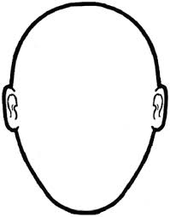

T 403-297-1402
E peer@cmha.calgary.ab.ca

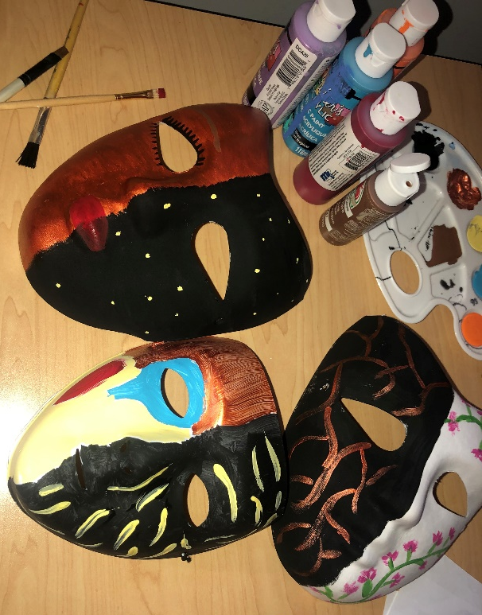
Examples

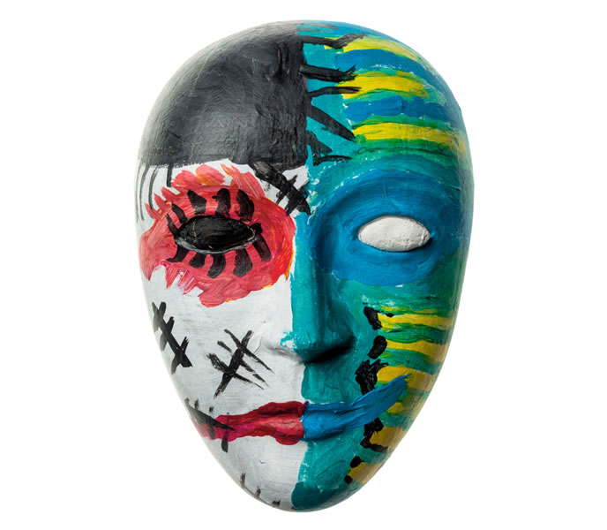
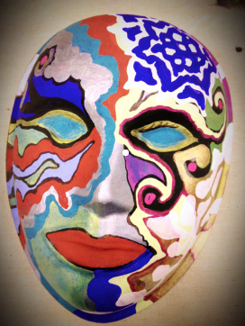
T 403-297-1402
E peer@cmha.calgary.ab.ca

